Problem Statement
You work at the United Nations urban-planning unit and need to quantify historical population growth of major cities to inform future resourcing. Starting with Istanbul (one of the world’s fastest-growing metros), calculate the average annual percentage growth rate between 1927 and 2017 using basic R syntax. The same reusable logic should later support any city or time window.

Solution Strategy
1. Store city name and the two endpoint populations in variables. 2. Compute absolute change, convert to percentage growth, then divide by elapsed years (arithmetic mean). 3. Wrap the calculation in a reusable function that also prints a narrative sentence. 4. Provide vector / data-frame alternates and a geometric-rate comparison. 5. Add a simulation block so parameters can be changed interactively.

Solution — Key R Snippets
Core result (1927–2017): Absolute change = 14 338 231; percentage growth ≈ 2 075 %; arithmetic annual ≈ 23.06 %/yr. Geometric annual (preferred) ≈ 3.48 %/yr.
Variable creation & arithmetic:
city_name <- "Istanbul, Turkey"
pop_year_one <- 691000
pop_year_two <- 15029231
pop_change <- pop_year_two - pop_year_one
percentage_gr <- (pop_change / pop_year_one) * 100
annual_gr <- percentage_gr / (2017 - 1927) # ≈ 23.05553
Function call (produces the narrative):
result <- calculate_annual_growth(
year_one = 1927, year_two = 2017,
pop_y1 = pop_year_one, pop_y2 = pop_year_two,
city = city_name)
→ “From 1927 to 2017 the population of Istanbul, Turkey grew by approximately 23.055525 % each year.”
Geometric alternative (more accurate for compounding):
geo_annual <- (15029231 / 691000)^(1/90) - 1
print(geo_annual * 100) # ≈ 3.48
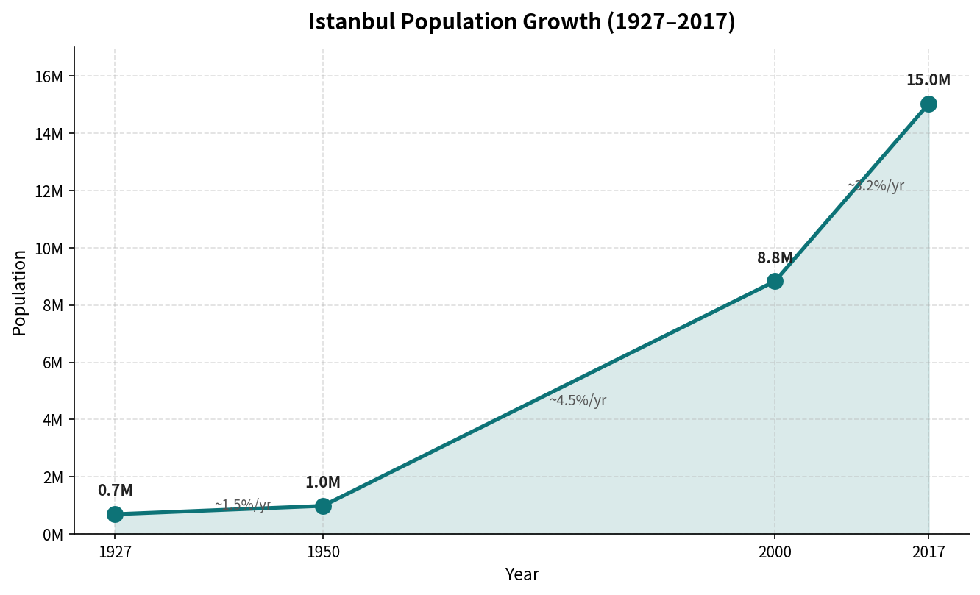
Figure: Istanbul population 1927–2017. Period rates: 1950–2000 ≈ 15.97 %/yr; 2000–2017 ≈ 4.13 %/yr.
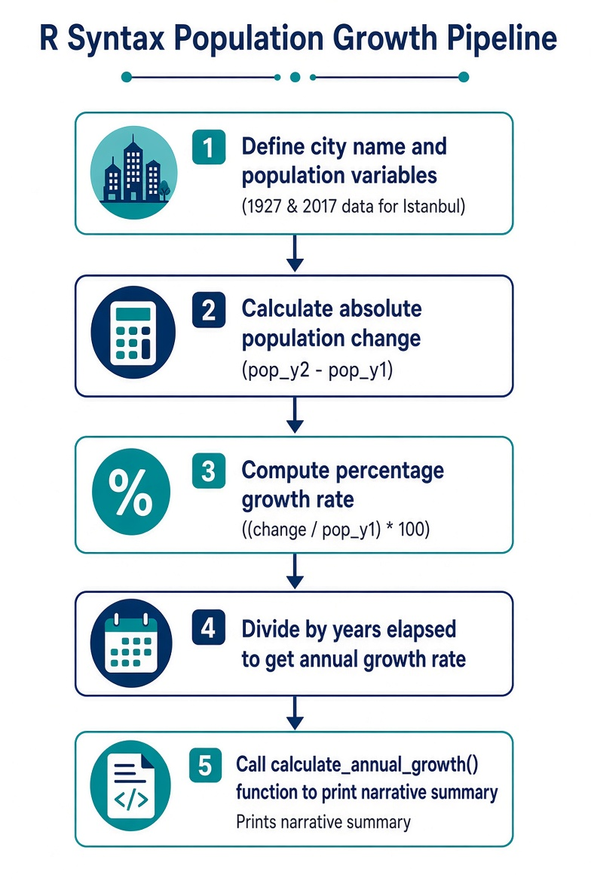
Figure: R Syntax Population Growth Pipeline.

Key Takeaways
• Variables + arithmetic + paste() turn raw census numbers into an actionable growth narrative.
• Named function arguments make the logic reusable across cities and time windows.
• Arithmetic averages are easy but can overstate long-horizon growth; always cross-check with the geometric rate.
• A parameterised simulation cell lets planners explore “what-if” futures without rewriting core code.
• Audience note: for executives keep the geometric rate + one-sentence narrative prominent; for technical staff expose both methods and intermediates.

